What follows is an itemized list on how a developer resource will create a New Project leveraging the Allstate APPFabric CLI Framework

 | Instructions | Description / Comments
1. | Make certain that the Project Engineer, Architect, andOr Owner has shared the necessary Project Information with you regarding this project. You will be unable to proceed without it. | Reference the AllState MarketPlace Instructions: d. Creating a New Project with Allstate MarketPlace  "Step #13" Contains the necessary information for you to be able to proceed:  a. Marketplace Fulfillment: New product created on PaaS Email  b. System Role ID Password Generated Email  It will contain the following information for your project  a. System Role ID & System Role ID Generated Password  b. BarometerIT Number  c. GitHub Location  d. Artifactory Location  e. PCF Location  f. Compliance Buddy Onboarding  g. Jenkins Pipeline
2. | Navigate to the following AllState APPFabric | https://github.allstate.com/pages/Engineering/AppFabric/
3 | Navigate to the following AllState APPFabric - Getting Started | Located in the Upper-Right-Hand Corner of the Menu Navigation  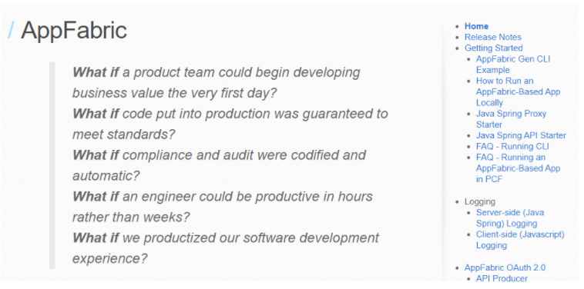
4 | Scroll down to section "Run the CLI" | Reference the following Link: https://github.allstate.com/pages/Engineering/AppFabric/docs/gettingStarted.html  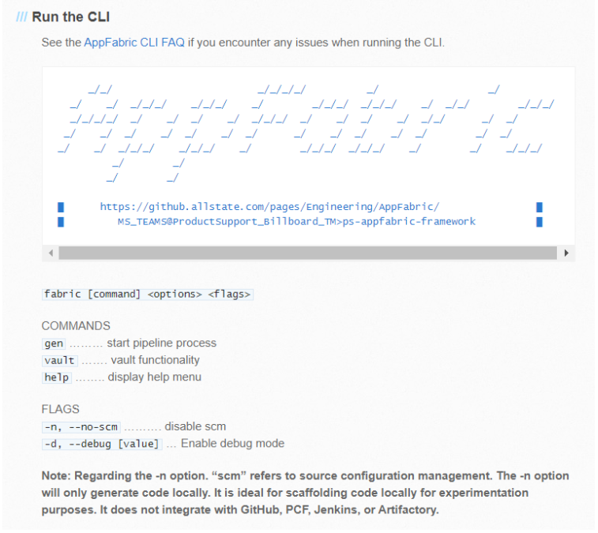
5. | Right-Click on the Desktop Shortcut Command Prompt and "Run Elevated with DefendPoint"  ***It is a always good practice to run applications as "Run Elevated with DefendPoint" | Opens Command Prompt
6. | Navigate to the C:\ Drive and Create a Project Workspace Directory | Enter the following Command-line Statement and Mash the ENTER KEY  a. mkdir workspace_test  ***Please give your project workspace a meaningful name, we have chosen "test" simply as an example  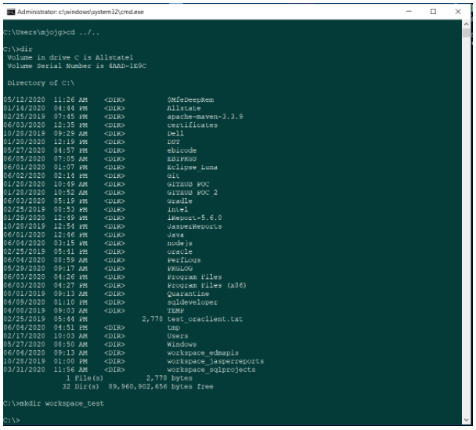
7. | Navigate to the newly created project workspace folder as shown in the screen-shot to the right. | 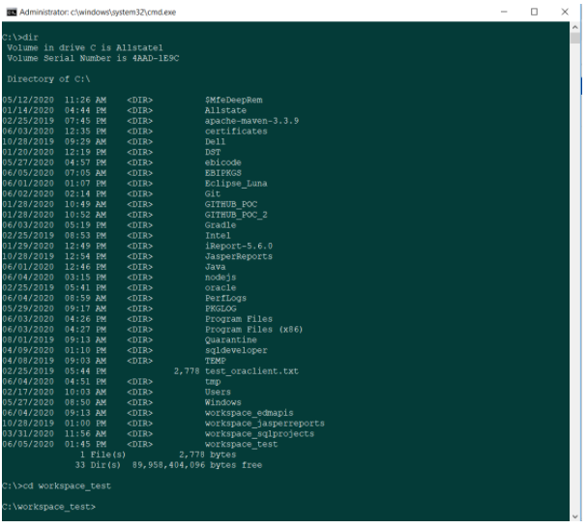
8. | Referencing Step #4, following the Allstate APPFabric Command Usage Generate a Project | At the command prompt enter and execute the following statement  (Reference the following link if necessary; https://github.allstate.com/pages/Engineering/AppFabric/docs/gettingStarted.html):  a. fabric gen  This will spin up the Allstate APPFabric Framework. Reference the Command Prompt Console Screen Shot below....  Also Note, navigation of this framework will require the use of the UP & DOWN ARROWS as well as the SPACE BAR for MENU ITEM SELECTION.  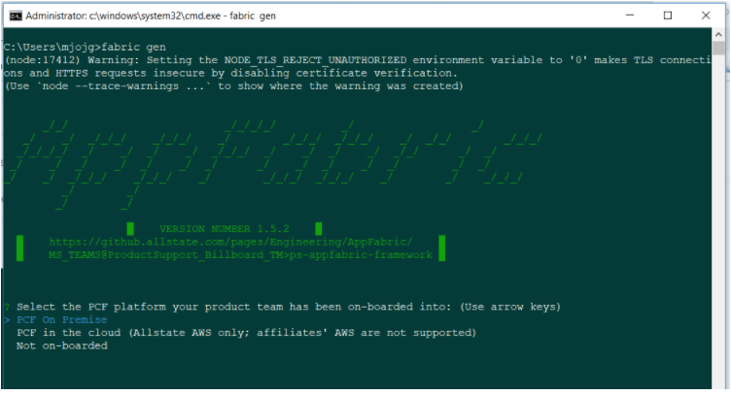
9. | Select the Default Choice "PFC on Premise" and mash the ENTER Key | Proceed
10. | Enter your Network Credentials at the console | 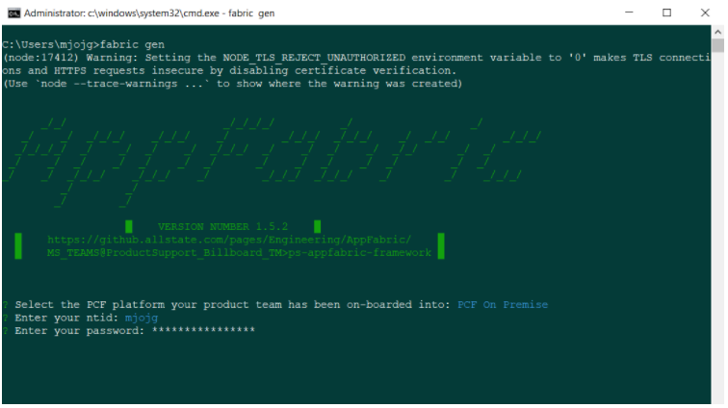
11. | For now enter "N" for the question "Will your API be secured by OAuth 2.0" | 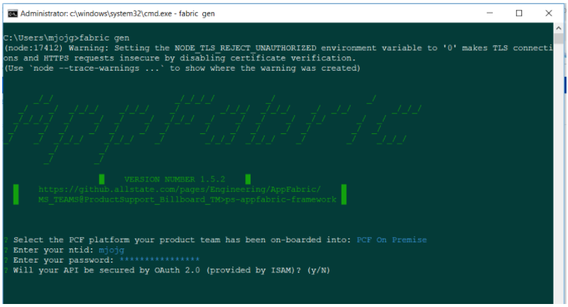
12. | This next step, "Which Components do you need?", is dependent upon your Projects Requirements;.  For our project we Selected the "API" & "PROXY" Options | 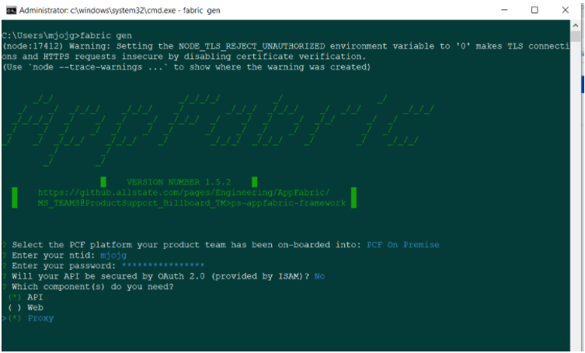
13 | This next step, "Lets Configure SCM - Which GitHub Organization", is dependent upon the information you have received in Step #1, above.  Here we have chosen "AB-DOCMGNT-PCF" This selection represents the Product Name, GitHub Location et cetera, that was provided in Step #1 Above | 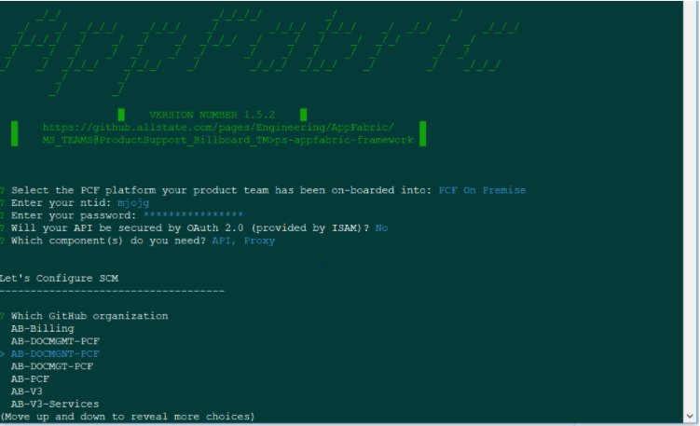
14 | This next step, "Lets Configure SCM - Which PCF Organization", is dependent upon the information you have received in Step #1, above.  Here we have chosen "AB-DOCMGNT-PCF" This selection represents the Product Name, GitHub Location et cetera, that was provided in Step #1 Above | 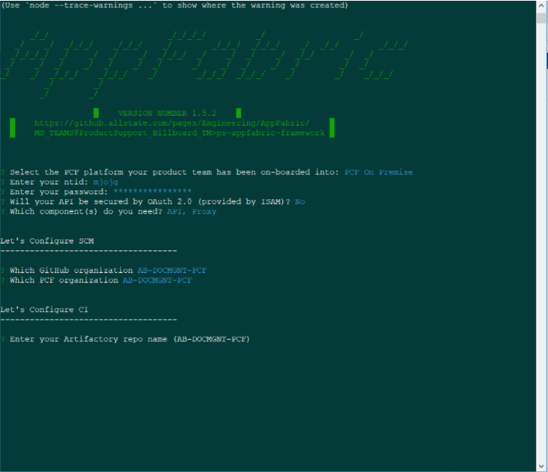
15 | This next step, "Lets Configure CI- Enter your Artifactory Repo Name", is dependent upon the information you have received in Step #1, above; however as you might see, we only have one option | If only one option exists simply MASH the ENTER KEY (AB-DOCMGNT-PCF). If not make the appropriate selection and MASH the ENTER KEY.
16 | This next step, "Lets Configure CI- Enter Product System Account Username", is dependent upon the information you have received in Step #1, above. | Enter Product System Account Username and MASH the ENTER KEY  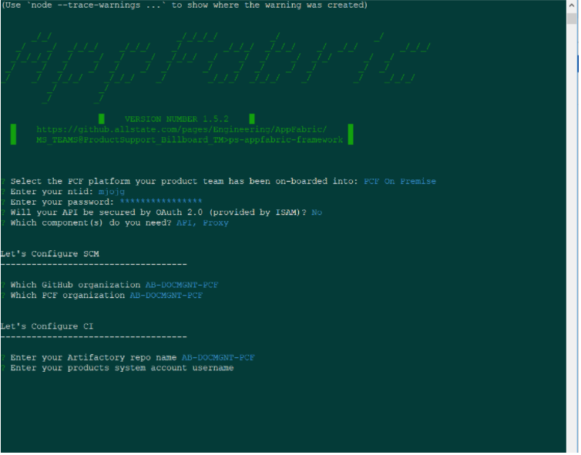
17 | This next step, "Lets Configure CI- Enter Product System Account Password", is dependent upon the information you have received in Step #1, above. | Enter Product System Account Password and MASH the ENTER KEY  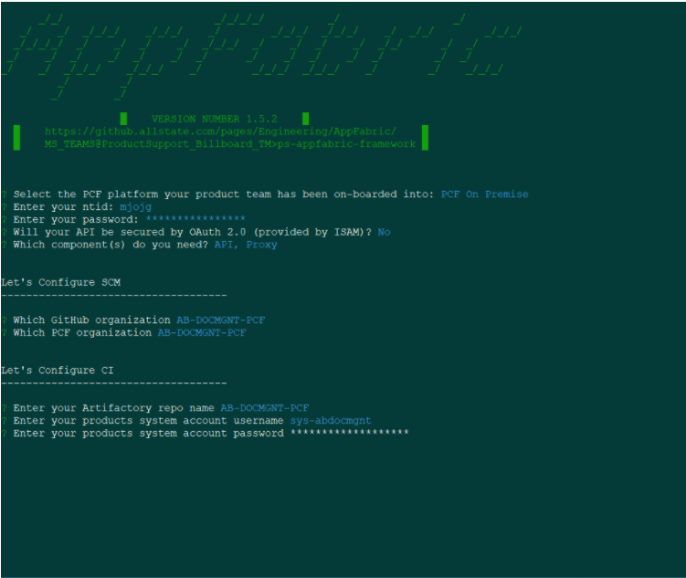
18 | Select your Service NOW Group (Use Arrow Keys)  Notice that the JenkinsClient throws an Exception: Unable to create Jenkins System Credential  Also, the functionality to "Select your Service NOW Group (Use Arrow Keys)" Is not very responsive, so simply MASH the ENTER KEY and RESOLVE the Service NOW Group later.  You may have to MASH the ENTER KEY a couple of times to get it to move forward... | 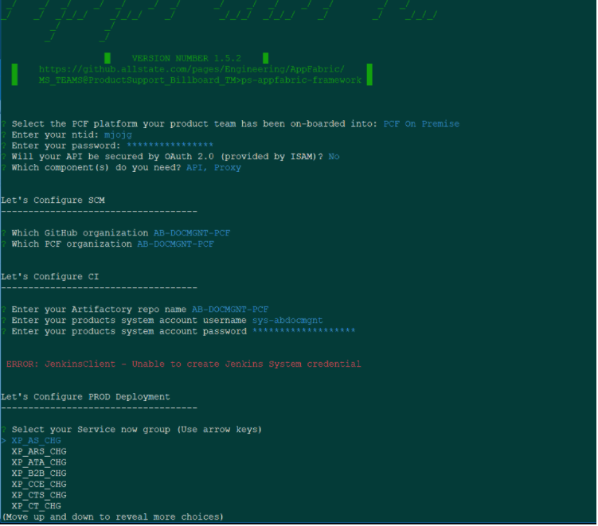
19 | This next step, "Lets Configure the API" - Enter Your JAVA Group | Enter a value specific to your project application.  As an example I am entering the value; com.allstate.compozed.docmgnt  MASH the ENTER KEY  ***This will determine your project application's API Package Naming Convention***  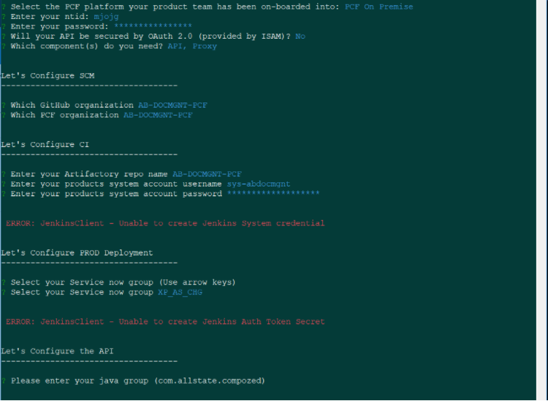
20 | This next step, "Lets Configure the API" Enter Your Project Name | Enter a value specific to your project application.  As an example I am entering the value; docmgnt  MASH the ENTER KEY  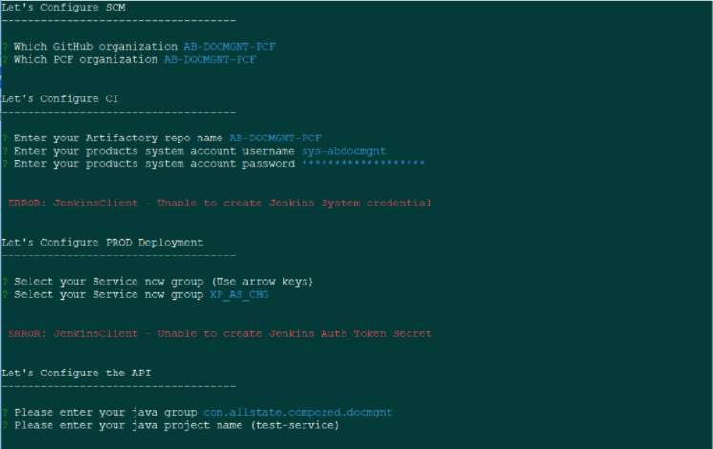
21 | This next step, "Lets Configure the Proxy" Enter Your Project Name  Notice, from the previous step the APPFabric performed the following:  a. Downloaded the Latest Templates  b. Generated the Code for the Service  c. Pushed the Code to the GitHub  d. Provided reminder to Clone the Repository | Enter a value specific to your project application.  As an example I am entering the value; docmgntproxy  MASH the ENTER KEY  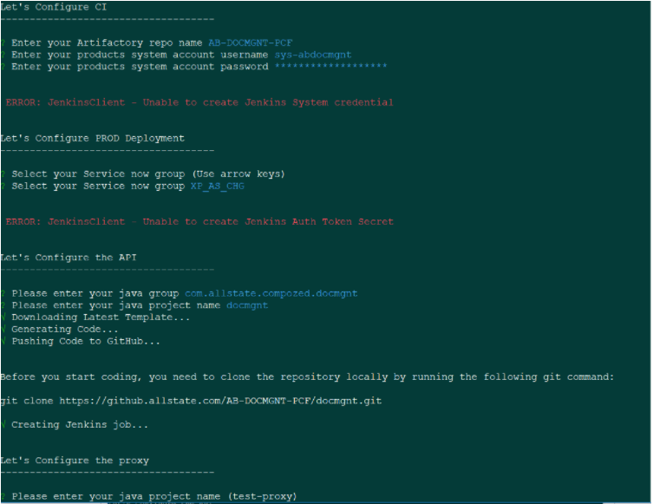
22 | Validate that the following was received at the console  Notice, from the previous step the APPFabric performed the following:  a. Downloaded the Latest Templates  b. Generated the Code for the Proxy  c. Pushed the Code to the GitHub  d. Provided reminder to Clone the Repository | 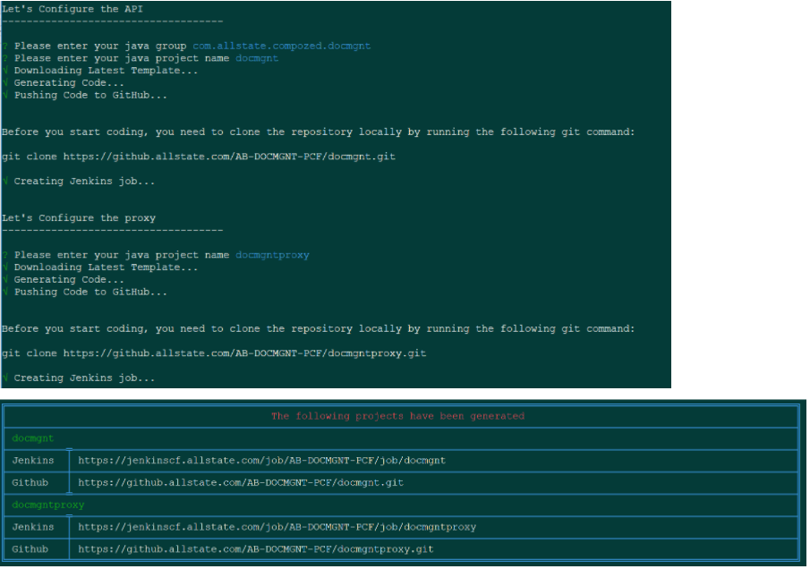  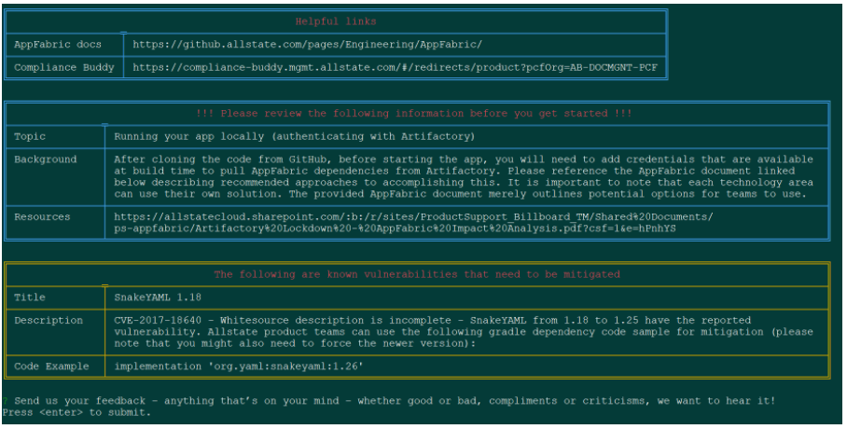
23 | Validate GitHub Code Creation  Links for this validation have been extracted from those shared within the AllState APPFabric Condole Message that have been captured within Step #22 Screen-shots  They have been provided to the right ONLY FOR REFERENCE, such that the end user will need to validate them. These repositories were for TRAINING PURPOSES ONLY and no longer exist per this writing. | Validate GitHub Code Creation  Proxy Repository: https://github.allstate.com/AB-DOCMGNT-PCF/docmgntproxy  Service Repository: https://github.allstate.com/AB-DOCMGNT-PCF/docmgnt
24 | Validate Jenkins Pipeline Creation  Links for this validation have been extracted from those shared within the AllState APPFabric Condole Message that have been captured within Step #22 Screen-shots  They have been provided to the right ONLY FOR REFERENCE, such that the end user will need to validate them. These repositories were for TRAINING PURPOSES ONLY and no longer exist per this writing. | Validate Jenkins Pipeline Creation  Proxy Repository: https://jenkinscf.allstate.com/job/AB-DOCMGNT-PCF/job/docmgntproxy  Service Repository: https://jenkinscf.allstate.com/job/AB-DOCMGNT-PCF/job/docmgnt
25 | Congratulations, you have successfully leveraged the AllState APPFabric CLI Framework to Generate Web Proxy and Service Boilerplate Code...

